Jerome Pitogo de Leon | 35-166337

HW3: Detecting planets via transits

1. Polly Photometer studies the star psi Cap. She has heard that this star has a Neptune-like planet orbiting it with a period of 2 years.
   1. Create a graph showing the (theoretical) V-band light curve of this star during a transit.

The transit depth, δ, is

$δ=(R_{p}/R_{s})^{2}$

where R_p and R_s are planet and star’s ratio. Knowing that Psi Cap is a F5V dwarf star (Gray et al. 2006) with typical radius is 1-1.4 R_sun, and using radius of Neptune should yield

$δ=(R_{Neptune}/R_{Sun})^{2}=(1.024e26/1.989e30)^{2}=0.0013$

Given the period of *p*=2 years, the orbital radius can be computed using Kepler’s 3rd law

$a = {(p}^{2}G(M_{S}+M_{p})/4π^{2})^{1/3}$ =1.586 AU

The transit duration, *T*, is

$T=p(R_{s}cos(δ)+R_{p})/πa=0.706$ days

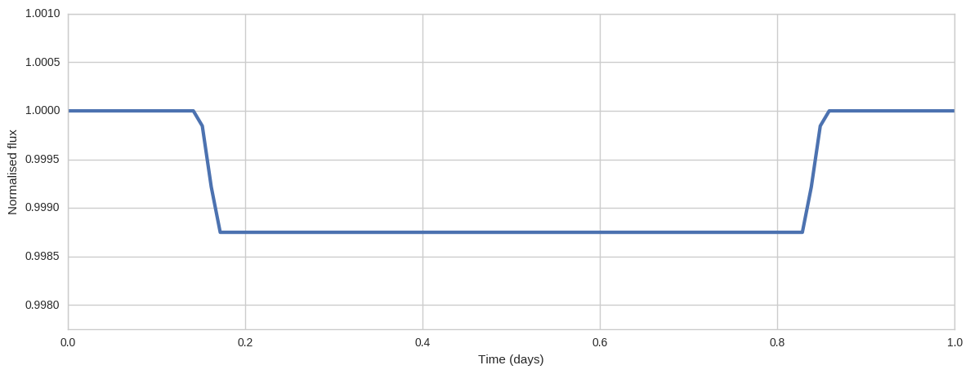

Fig. 1. Normalized V-band lightcurve of Psi Cap.

* 1. Create a graph showing the (theoretical) V-band light curve of this star during one full orbit of the planet. Assume that the albedo of the planet's clouds is **a = 0.5.** Make a closeup around the time of the secondary eclipse (= occultation = when the planet goes behind the star). Make sure that your scales on the time and magnitude axes are accurate.
  2. **Bonus!** Polly has access to a 1-m space telescope with an expensive CCD. Should she apply for time to observe this star and actually confirm the presence of this planet? Should she ask for time around both primary and secondary eclipses? Justify your answer.

The contrast between the planet and star in the V-band is ratio of their luminosities

The flux from the star is

W/m2

The solar irradiance of the star onto the planet is

W/m2

Taking into account the albedo, A, of the planet, the flux from the planet is

W/m2

Thus, the delta mag

$ΔV=-2.5log(\frac{fs-f_{p}}{f_{s }+f_{p}})=2.69×10^{-8}$ mag

In this case, it is impossible to measure such delta V. It is therefore wiser to observe only the primary eclipse to save precious and expensive telescope time. Such proposal might also get more chance of being accepted given shorter observation time requirement.

1. Polly decides to look at a different star instead. She acquires the following photometric measurements during one transit.
2. 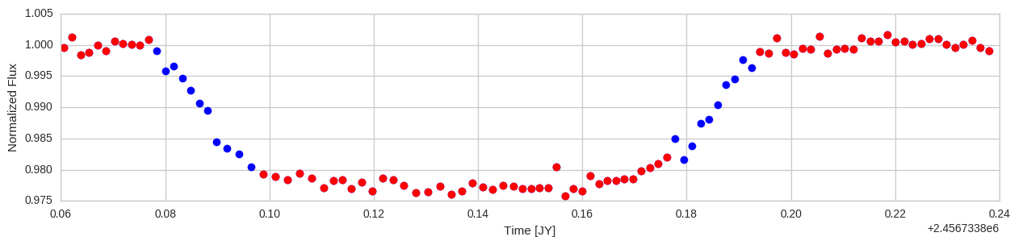
   1. What is the depth of this transit?

The transit depth, δ, can be crudely estimated from

lc_max = mean(red points in the top)

lc_min = mean(red points in the bottom)

delta = lc_max - lc_min = 0.022

* 1. What is the duration of this transit?

The transit duration, *T*, is

*T* = t[t4]-t[t1]=0.116 day

where t1:t4 corresponds to key points in egress and ingress.

* 1. What is the time of mid-transit?

t0 = ( t [ (t4-t1) / 2) + t1 ] / 2

Estimated t0 = 1228366.9704 JY

* 1. (**Bonus!**) Polly finds in a textbook that limb-darkening is sometimes expressed in the following manner. If **θ** is the angle between the line of sight to the observer and the line from the center of the star to a point on the photosphere, then the intensity of that point **I** relative to the intensity at the center of the disk **I0** is

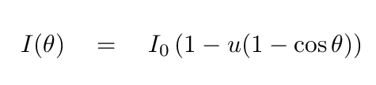

* 1. What is the value of the coefficient **μ** which fits this data best?
  2. **Bonus!** This is a real exoplanet. Which one?

It seems this is a Kepler planet given the relevant parameters. It is unfortunate that the NexSci database was down during writing.

1. Aliens are everywhere, and they have telescopes! Every single star within 25 parsecs of the Sun has an alien astronomer, and all of them are constantly monitoring the Sun.
   1. How many of these astronomers will be able to see a transit by the Earth?

Assume that the space density of all main-sequence stars in the solar neighborhood is 0.1 stars per cubic parsec. The total number *N* of stars (of all types) within 25 pc is just the volume *V* contained by a sphere of radius 25 pc times the space density of stars ρ.

$N=ρV=(0.1) * 4π(25 pc)^{3}/3 =6544$ stars

Supposing all the *N* stars are sun-like, then the probability of transit p_trans is

$p_{trans }=(\frac{R_{s} +R_{p}}{a})(\frac{1-e sin w}{1-e^{2}}) ≅\frac{R_{s} +R_{p}}{a}=$ 0.004696

assuming *e*=0 and *w*=90 deg.

Thus, the estimated number of Earth observable transiting planets in Earth-orbits within 25 pc is

$n=N*p_{trans}≅ 30$ planets

Alternatively, using the value *N*=2150[1] stars in the catalog of Woolley et al. 1970, we get

$n=N*p_{trans}≅ 10$ planets

* 1. How many of these astronomers will be able to see a transit by any planet?

1. http://vizier.cfa.harvard.edu/viz-bin/VizieR?-source=V/32A